DDD HOMEWORK

To put in a client name select all (ctrl A) then f9Harvey Nash Software Development

**Detailed Design**

**Version 1.0**

**7th Nov, 2013**

364 Cong Hoa Street

Harvey Nash Viet Nam

Tel: +44 (0)20 7333 0033

Fax: +44 (0)20 7333 0032

Email: [tho.lechi@harveynash.vn](mailto:tho.lechi@harveynash.vn)

DOCUMENT HISTORY

|  |  |  |  |  |
| --- | --- | --- | --- | --- |
| **Document Version History** | | | | |
| **Version** | **Date** | **Author** | **Reviewer** | **Details** |
| 1.0 | 22 Nov 2013 | Tho Chi Le |  | Create |

**APPROVERS**

|  |  |  |  |
| --- | --- | --- | --- |
|  | Name & Role | Date | Signature |
| **Originator** |  |  |  |
| **Reviewer/s** |  |  |  |
| **Approver/s** |  |  |  |

CONFIDENTIALITY

This document is distributed on a restricted basis, is commercial in confidence to the recipient, and may not be used for any purpose other than that associated with a Harvey Nash project. The contents of this document may not be disclosed to any third parties without the expressed advance written authorisation of Harvey Nash.

TABLE OF CONTENTS

CONFIDENTIALITY 1

1 INTRODUCTION 4

1.1 Purpose 4

1.2 Scope 4

1.3 Definitions, Acronyms and Abbreviations 4

1.4 References 4

1.5 Overview 4

2 DESIGN SEPECIFICATION FOR UC_DDDHOMEWORK 4

2.1 Summary 4

2.2 Use case diagram 4

2.3 Activity Diagram 5

2.3.1. Login Activity Diagram 5

2.3.2. View Topic Activity Diagram 5

2.3.3. Post Topic Activity Diagram 6

2.3.4. Discuss Topic Activity Diagram 6

2.3.5. Delete Topic Activity Diagram 7

2.3.6. Lock Topic Activity Diagram 7

2.3.7. Unlock Topic Activity Diagram 8

2.4 Sequence Diagram 8

2.4.1. Login Activity Diagram 8

2.4.2. View Topic Activity Diagram 9

2.4.3. Post Topic Activity Diagram 9

2.4.4. Discuss Topic Activity Diagram 10

2.4.5. Delete Topic Activity Diagram 10

2.4.6. Lock Topic Activity Diagram 11

2.4.7. Unlock Topic Activity Diagram 11

2.5 Screens Design 12

2.6 Class Diagram 12

2.7 Class Specification (s) 12

2.7.1. Classes Summary 12

2.7.2. Class Details 12

**2.7.2.1.** **Class Topic** 12

**2.7.2.1.1.** **Attributes** 12

**2.7.2.1.2.** **Methods** 13

**2.7.2.1.3.** **[ViewTopic] Method** 13

**2.7.2.1.4.** **[PostTopic] Method** 13

**2.7.2.1.5.** **[DeleteTopic] Method** 14

**2.7.2.1.6.** **[LockTopic] Method** 14

**2.7.2.1.7.** **[UnlockTopic] Method** 15

**2.7.2.2.** **Class User** 15

**2.7.2.2.1.** **Attributes** 15

**2.7.2.2.2.** **Method** 15

**2.7.2.2.3.** **[Login]Method** 16

**2.7.2.3.** **Class TopicDiscuss** 17

**2.7.2.3.1.** **Attributes** 17

**2.7.2.3.2.** **Method** 17

**2.7.2.3.3.** **[DiscussTopic]Method** 17

# INTRODUCTION

This document acts step by step the process business executable

## Purpose

This document acts developer understand clearly what must to do.

## Scope

This document applies to all developer who working in DDD Homework project – Harvey Nash company

## Definitions, Acronyms and Abbreviations

|  |  |
| --- | --- |
| **Acronym** | **Reference** |
| User | Who use system |

## References

## Overview

# DESIGN SEPECIFICATION FOR UC_DDDHOMEWORK

## Summary

This use-case authentication

## Use case diagram



## Activity Diagram

### Login Activity Diagram



### View Topic Activity Diagram



### Post Topic Activity Diagram



### Discuss Topic Activity Diagram



### Delete Topic Activity Diagram



### Lock Topic Activity Diagram



### Unlock Topic Activity Diagram



## Sequence Diagram

### Login Activity Diagram



### View Topic Activity Diagram

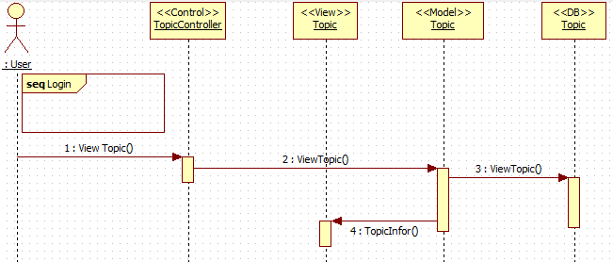

### Post Topic Activity Diagram

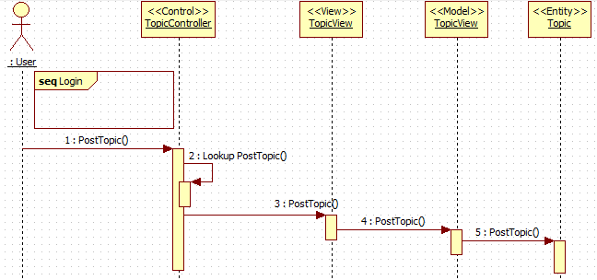

### Discuss Topic Activity Diagram

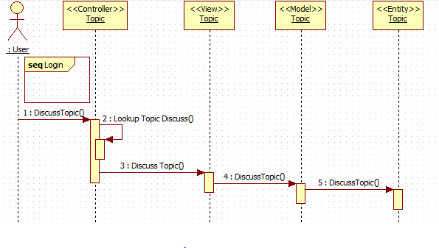

### Delete Topic Activity Diagram

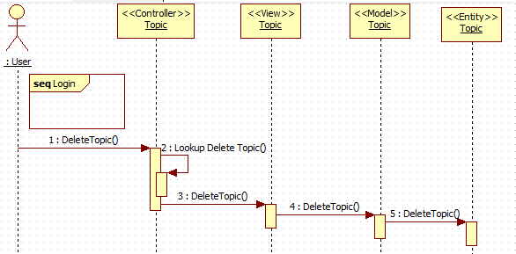

### Lock Topic Activity Diagram

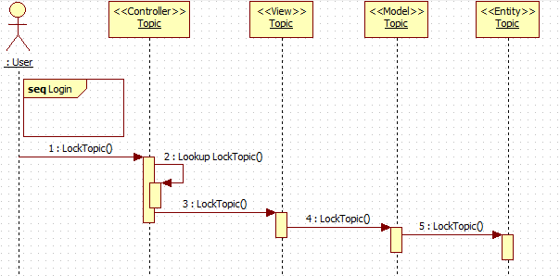

### Unlock Topic Activity Diagram

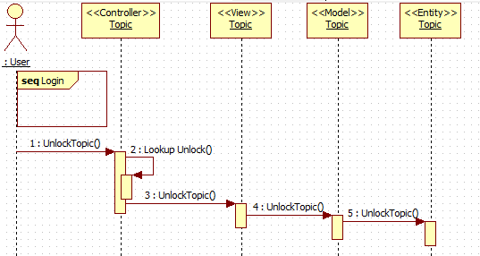

## Screens Design

## Class Diagram



## Class Specification (s)

### Classes Summary

### Class Details

#### **Class Topic**

#### **Attributes**

|  |  |  |  |  |  |
| --- | --- | --- | --- | --- | --- |
| No | Attribute | Type | Default | Note | Description |
| 01 | TopicId | String |  | Public | Id of topic |
| 02 | Name | String |  | Public |  |
| 03 | Creator | String |  | Public |  |
| 04 | CreateDate | Datetime |  | Public |  |
| 05 | DiscussId | String |  | public |  |

#### **Methods**

|  |  |  |
| --- | --- | --- |
| No | Method | Description |
| 01 | ViewTopic(string TopicID) | View content of topic |
| 02 | PostTopic() | Post a new topic |
| 03 | DeleteTopic(string TopicId) | Delete a topic |
| 04 | LockTopic(string TopicId) | Lock a topic |
| 05 | UnlockTopic(string TopicId) | Unlock a topic |

#### **[ViewTopic] Method**

|  |  |
| --- | --- |
| **Declaration** | |
| **Method Declaration** | **Public ActionResult ViewTopic(string TopicId)** |
| **Description** | View the content of topic |
| **Overrides** | |
| Not Applicable. | |
| **Parameter** | |
| **Name** | **Type** |
| **TopicId** | **string** |
| **Return Type** | |
| View | |
| **Throws** | |
|  | |

#### **[PostTopic] Method**

|  |  |
| --- | --- |
| **Declaration** | |
| **Method Declaration** | **Public ActionResult PostTopic()** |
| **Description** | Create a new topic |
| **Overrides** | |
| Not Applicable. | |
| **Parameter** | |
| **Name** | **Type** |
|  |  |
| **Return Type** | |
| View | |
| **Throws** | |
|  | |

#### **[DeleteTopic] Method**

|  |  |
| --- | --- |
| **Declaration** | |
| **Method Declaration** | **Public ActionResult DeleteTopic(string TopicId)** |
| **Description** | Delete a topic |
| **Overrides** | |
| Not Applicable. | |
| **Parameter** | |
| **Name** | **Type** |
| **TopicId** | **string** |
| **Return Type** | |
| View | |
| **Throws** | |
|  | |

#### **[LockTopic] Method**

|  |  |
| --- | --- |
| **Declaration** | |
| **Method Declaration** | **Public ActionResult LockTopic(string TopicId)** |
| **Description** | Lock a topic |
| **Overrides** | |
| Not Applicable. | |
| **Parameter** | |
| **Name** | **Type** |
| **TopicId** | **string** |
| **Return Type** | |
| View | |
| **Throws** | |
|  | |

#### **[UnlockTopic] Method**

|  |  |
| --- | --- |
| **Declaration** | |
| **Method Declaration** | **Public ActionResult UnlockTopic(string TopicId)** |
| **Description** | Unlock a topic |
| **Overrides** | |
| Not Applicable. | |
| **Parameter** | |
| **Name** | **Type** |
| **TopicId** | **string** |
| **Return Type** | |
| View | |
| **Throws** | |

##### Implementation

#### **Class User**

#### **Attributes**

|  |  |  |  |  |  |
| --- | --- | --- | --- | --- | --- |
| No | Attribute | Type | Default | Note | Description |
| 01 | UserId | String |  | Public | Id of topic |
| 02 | FirstName | String |  | Public |  |
| 03 | LastName | String |  | Public |  |
| 04 | Address | String |  | Public |  |
| 05 | DateOfBirth | Datetime |  | public |  |
| 06 | Username | String |  | Public |  |
| 07 | Password | String |  | public |  |

#### **Method**

|  |  |  |
| --- | --- | --- |
| No | Method | Description |
| 01 | Login(string username, string password) | Login system |

#### **[Login]Method**

|  |  |
| --- | --- |
| **Declaration** | |
| **Method Declaration** | **Public ActionResult Login(string Username, string Password)** |
| **Description** | Login system |
| **Overrides** | |
| Not Applicable. | |
| **Parameter** | |
| **Name** | **Type** |
| **Username** | **string** |
| **Password** | **string** |
| **Return Type** | |
| View | |
| **Throws** | |
|  | |

#### **Class TopicDiscuss**

#### **Attributes**

|  |  |  |  |  |  |
| --- | --- | --- | --- | --- | --- |
| No | Attribute | Type | Default | Note | Description |
| 01 | DiscussID | String |  | Public | Id of topic |
| 02 | TopicID | String |  | Public |  |
| 03 | UserID | String |  | Public |  |
| 04 | DiscussContent | String |  | Public |  |
| 05 | DiscussDate | Datetime |  | public |  |

#### **Method**

|  |  |  |
| --- | --- | --- |
| No | Method | Description |
| 01 | DiscussTopic(TopicDiscuss _topicdiscuss) | Discuss a topic |

#### **[DiscussTopic]Method**

|  |  |
| --- | --- |
| **Declaration** | |
| **Method Declaration** | **Public ActionResult DiscussTopic(TopicDiscuss _topicDiscuss)** |
| **Description** | Discuss a topic |
| **Overrides** | |
| Not Applicable. | |
| **Parameter** | |
| **Name** | **Type** |
| **_topicDiscuss** | **TopicDiscuss** |
| **Return Type** | |
| View | |
| **Throws** | |
|  | |